 **First Quarter 2023**  
WETHERSFIELD, October 25, 2023 - Business Employment Dynamics (BED) data published quarterly by the Bureau of Labor Statistics tracks employment change at the establishment level and reveals the underlying dynamics of net employment change. The data include gross employment change, business expansion/contraction, establishment birth/death, and is available at sector level.   
  
From January 2023 to March 2023, **gross job gains** from opening and expanding private sector establishments in Connecticut was 87,749, a 3,353 job increase from the previous quarter. Over this period, **gross job losses** from closing and contracting private sector establishments was 75,054, a decrease of 9,825 from the previous quarter.   
  
During the first quarter of 2023, the difference between gross job gains and gross job losses yielded a **net** **employment increase** of 12,695 jobs in the private sector. This net increase follows a 483 net decrease during the fourth quarter of 2022.

**BUSINESS EMPLOYMENT DYNAMICS  
Office of Research  
Danté Bartolomeo, Commissioner  
Patrick Flaherty, Director of Research**

Net employment change reached a low of -203,916 during the second quarter of 2020. The combined net change for the eleven quarters of subsequent data through the first quarter of 2023 is 182,408 jobs.

The change in the number of jobs over time is the net result of increases and decreases in employment that occur at all businesses in the economy. Business Employment Dynamics (BED) statistics track these changes in employment at private business units from the third month of one quarter to the third month of the next. Gross job gains are the sum of increases in employment from expansions at existing units and the addition of new jobs at opening units. Gross job losses are the result of contractions in employment at existing units and the loss of jobs at closing units. The difference between the number of gross job gains and the number of gross job losses is the net change in employment.

The BED data series includes gross job gains and gross job losses at the establishment level by industry subsector and for the 50 states, the District of Columbia, Puerto Rico, and the Virgin Islands, as well as annual gross job gains and annual gross job losses at the firm level by employer size class.

Gross job gains at **expanding** establishments totaled 69,509 in the first quarter of 2023, an increase of 2,604 from the previous quarter.

**Opening** establishments accounted for 18,240 jobs gained in the first quarter of 2023, an increase of 749 jobs from the previous quarter.

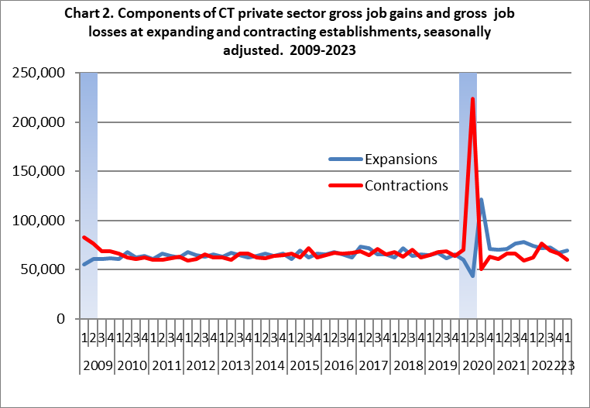

**Contracting** establishments lost 59,747 jobs in the first quarter of 2023, a decrease of 6,229 from the prior quarter.

In the first quarter of 2023, **closing** establishments lost 15,307 jobs, a decrease of 3,596 from the previous quarter. Chart 3 shows the relationship between opening and closing-derived job change. Beginning in 2019, opening and closing-derived job change was above 2011-18 levels. During 2020Q2, the impact of the recession is illustrated by the large uptick in closing job losses and the large uptick in openings the following quarter. In the first quarter of 2023, employment change at openings and closings resulted in a 2,933 net employment increase during the first quarter of 2023. This follows a 1,412 net decrease during the fourth quarter of 2022.

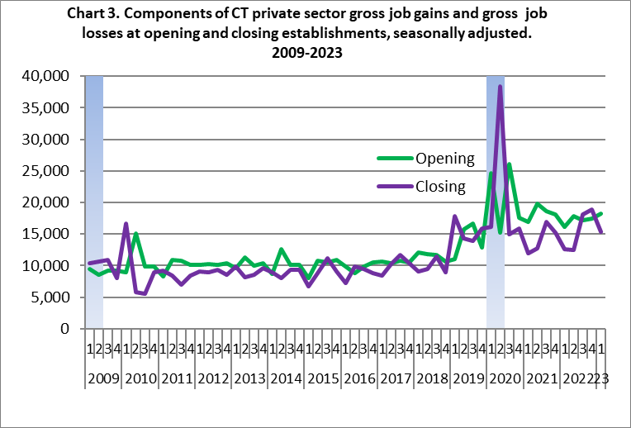

In the first quarter of 2023, there were 4,331 **establishment births** (a subset of the openings data). These new establishments accounted for 10,415 jobs, 1,198 less than the previous quarter.

Data for **establishment deaths** (a subset of the closings data) are available through the second quarter of 2022, where 7,351 jobs were lost at 3,122 establishment deaths. In the prior quarter, 6,837 jobs were lost at 2,883 establishment deaths.

The **net change** of **establishment births and deaths** went consistently negative during the Great Recession in Connecticut from the first quarter of 2008 through the first quarter of 2010. During those 9 quarters of net decline, Connecticut averaged a net decrease of 640 establishments per quarter, with the largest net establishment decline occurring at the end of the recession, down 1,784 in the first quarter of 2010. From 2010Q2-2018Q4, it ranged between   
-354 and +903 quarter-to-quarter change.   
  
During the first half of 2019, net change fell by 1,945 establishments in the first quarter and 544 in the second. It recovered to a 57 establishment increase in the third quarter and fell by 153 in the fourth quarter of 2019. During the first quarter of 2020, net establishment births and deaths was up 4,111 and fell 1,565 during the second quarter of 2020. After the 2020 recession, net establishment change averaged a gain of 1,334 per quarter from the third quarter of 2020 through the first quarter of 2022. During the second quarter of 2022 (the most recent quarter available), net gains were 941.

During the first quarter of 2023, **gross job gains** exceeded **gross job losses** in 7 of 10 industries. The largest net increases occurred in Leisure & Hospitality (+4,246 jobs) and Educational & Health Services (+3,819 jobs). The three net decreasing industries were Transportation & Warehousing (-2,039 jobs), Financial Activities (-351 jobs), and Manufacturing (88 jobs).

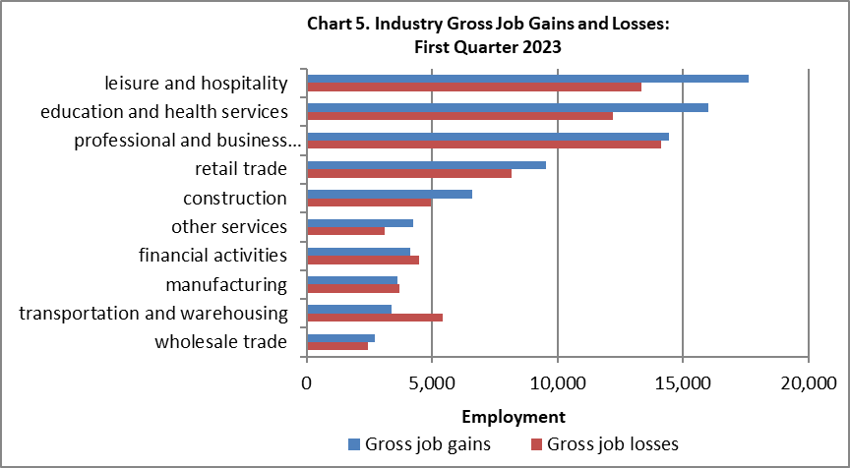

Additional Information on Business Employment Dynamics, including data for the United States, 50 states, and US territories can be found at: <http://www.bls.gov/bdm/>.



A Note About the Data:

The Business Employment Dynamics (BED) data are generated from Connecticut’s unemployment insurance (UI) records, enhanced through procedures conducted in association with the Bureau of Labor Statistics, and cover approximately 93% of all wage and salary workers in the state. The BED program links these records across quarters, providing a longitudinal history of employment for each establishment. These longitudinal records allow the identification of employment changes at expanding, opening, contracting, or closing establishments. Aggregating these changes, the BED data identify the gross job gains and losses, also known as job flows, in the state. These flows provide an understanding of the labor market dynamics that unfold over time. The job flows data scratches below the surface to expose the undercurrents that result in the net employment outcomes reported in other statistical series

The net change in employment from the Business Employment Dynamics data series will not match the net change in nonfarm employment produced from the monthly survey and reported in the Labor Situation. The monthly estimates are based on surveys from a sample of establishments, while the BED data are based on a quarterly census of administrative records. In addition, the monthly series has a different coverage, excluding the agriculture sector but including government, private households, and establishments not covered by the unemployment insurance program. Thus, the net over-the-quarter changes derived from the BED data may be different from the net employment change estimated from the monthly nonfarm employment series. The intended use of the BED statistics is to show the dynamic labor market flows that underlie the net changes in aggregate employment levels; data users who want to track net changes in aggregate employment levels over time should refer to monthly nonfarm data.

With the release of first quarter data each year, seasonally adjusted data for prior periods are revised and will therefore be different than figures shown in earlier releases. Please see <http://www.bls.gov/bdm/> for more

detailed information.

This publication was prepared by Matthew Krzyzek, Economist at the Connecticut Department of Labor, Office of Research. If you have any questions regarding this publication, please call (860) 263-6287 or Matthew.Krzyzek@ct.gov.